**DÉPARTEMENT Informatique**

**Projet d’intégration**

**Online purchasing center**

Réalisé à

**Esprit**

**Soutenu le 09/02/2023**

**L’equipe The Creators**

|  |  |  |  |  |  |
| --- | --- | --- | --- | --- | --- |
|  |  | **Nihed Attia** | | | |
|  |  | **Mazen Slama** | | | |
| **Weal Talbi** | | |
|  |  | **Anis Nasri**  **Achref Elj**  **Oussema ben Romdhane** | | | |
| **Encadrant ESPRIT** | | | | **:** | **M./Mme** | | **Ons Ben Salah** |

Année Universitaire : 2022/2023

Remerciements

Table of Contents

Remerciements 1

Table of Contents 2

Table of figures 3

List of tables 4

General Introduction 5

Chapter 1 : State of the art 6

Introduction: 7

1.1. Preliminary study 7

1.1.1. Problematic 7

1.1.2. Goals 7

1.1.3. Existing Solution 8

1.1.4. Critic of the existing solutions 8

1.1.5. Proposed Solution 9

9

1.1.6. Requirements and specifications 10

1.1.6.1. Functional requirement 10

1.1.7. Other Requirements 12

1.1.7.1. Non functional requirements 12

1.1.8. General Use cases 13

1.1.9. Conception class diagram 14

14

1.2. Global architecture of the solution 15

1.2.1. Physical Architecture 15

1.2.2. Logical Architecture 16

1.2.3. MVC 16

1.2.4. Deployment diagram 17

1.2.5. Work environment 18

General Conclusion 22

Table of figures

Figure 1: General Use Case 13

Figure 2: Analysis class diagram 14

Figure 3: Physical Architecture 15

Figure 4: Three-tier architecture 15

Figure 5: Logical Architecture 16

Figure 6: MVC architectural 17

Figure 7: Deployment diagram 17

Figure 8: Asus-Rog-Strix 18

Figure 9:Windows11 Logo. 18

Figure 10: Spring Tool Suite (STS) IDE 18

Figure 11: intelli idea 19

Figure 12: MySQL 19

Figure 13: Lucidchart 19

Figure 14: Github 19

Figure 15: SpringBoot Logo 20

Figure 16: Angular Logo 20

Figure 17: Angular Material 20

Figure 18: Bootstrap 20

List of tables

General Introduction

The expansion of the Internet is causing profound changes in the commercial world, from advertising to delivery, all the details of a commercial relationship between the seller and the customer and the customer pass. Today by the Internet, this last one puts at the disposal of all the partners, all the tools to finalize the purchase and the sale successfully and safely, what is called today the e-Commerce . We move from hand-to-hand sales to virtual sales, which makes it necessary to give more importance to the electronic sale.

Online stores have been widely recommended for years for companies that are based on the sale of products and even services. These types of websites represent a global device providing customers with a bridge to all information, and services from a single portal related to its activity.

The online sales sites allow customers to enjoy a virtual shopping mall which allows them to never miss their favorite items, so that they never miss a fair without problems of geographical distance nor of work schedule nor of transport availability. On the other hand, these sites offer the company to take advantage of this space to expose its products to a larger customer base.

Our PIDEV project is a Web application used to automate the entire purchasing process, including the management and the process from the purchase request to the billing which is a project proposed by the company "Hydatis".

# : State of the art

Introduction:

This chapter is dedicated to putting the project into context, indicating its activities as well as the values of this company in a first, then to develop the problem of the subject and the proposed solution. Finally, a description of the adopted technologies and methodologies.

* 1. Preliminary study
     1. Problematic

Today the e-Commerce becomes more and more one of the strongest services of the Internet, and this is due to the diffusion of the information on the web that is fast and cheap, which allows an advertising expansion of a new product, with a very economic advertising cost, which encourages the companies offering the sales service to choose the ecommerce.

For the same reasons as mentioned above, Hydatis has decided to create a dynamic Web Application which will answer the following needs:

- We automate the entire purchasing process.

- To allow the providers and the operators to sell their products on the web.

- To allow customers to place orders via the web.

- To allow delivery personnel to deliver orders to customers.

Our work should answer the following questions:

How can we sell and collect payment while being in distance of customers?

How can we help SpeedShop application to expose its products to a wider customer base?

* + 1. Goals

Our goal is to create an application that provides the customers a space to buy their needs and a space for the operators and the Operators to sell their products and a space for delivery persons can use to work and deliver the orders to their customers.

So, we build Web application used to automate the entire purchasing process, including the management and follow-up of the process from the purchase request to the billing.

* + 1. Existing Solution

|  |  |  |  |
| --- | --- | --- | --- |
| Website | Jumia | MyTek | WAMIA |
| Description | Founded in 2012, Jumia is an e-commerce company dominating the african market and existing in Tunisia since 2016.  It’s a complete ecosystem that meets the needs of Africa's rapidly growing middle class daily lives | Mytek is the leader in the sale of computer equipment in Tunisia since 2004. With an experience of more than 10 years and made up of a team of enthusiasts of new technologies, the company of sale of High Tech products manages to satisfy the most demanding customers. | is an online sales company of various products based in Sousse which offers the most diversified offer in e-commerce, all with delivery throughout Tunisia and a service dedicated to satisfying its customers. |
| Advantages  (+) | -Target according to a theme (valentine's day, etc.).  - Various deliveries (home, relay point).  -Various payments (on delivery, credit card).  - Modern design.  - UX / UI clear. | - Possibility to pay on delivery. | Dynamic search.  -Possibility to pay on delivery.  -Varied delivery (at home,store pickup).  -High security (check then email to retrieve the account). |
| Disadvantages  (-) | So many adds.  -Very sensitive search and is not precise (sometimes the product is available but is not taken into account ).  -Low account security ( if I forgot my password I can retrieve it from my mail without generating a code ). | -Cart available to everyone without registration (add to the basket without authenticating) - Overcrowded design.  -Log in/ create an account invisible throughout the site.  -Connection with FaceBook does not work. | (-): -Cart available for everyone without registration..  -Place the order without creating an account or log in.  -Empty content sometimes.  -Poorly organized subpages (design and content level) |

Tableau 1: Existing Solution

* + 1. Critic of the existing solutions

After studying the existing solutions, we found that they lacked many services, had limited interaction between colleagues, and that none of the applications on the proposed list offered all the features we were looking for.

Each solution in this list has its own advantages and disadvantages but none of them offers all the services we are looking for.

That's why we are going to create a web application that facilitates and correctly helps customers to connect, search for any product that want to buy it, so that suppliers and operators can sell their items at very competitive prices. As well as it will have the role of deliver person to deliver these orders to the appropriate customers.

* + 1. Proposed Solution

To solve the above problems, we propose the design and implementation of a web application that offers you a bigger range of services than the other available apps on the market, in order to automate the entire purchasing process, including management and monitoring of the process from the purchase request to the invoicing. like:

- Give the opportunity to providers and operators to submit their product in the web application in order to sell them.

- Exhibition of the products as well as their prices and characteristics by their suppliers and operators.

- Consult lists of product’s posts and manage an order.

- There is the role of a delivery person who will bring the orders to the corresponding customers.

- Online payment by credit Card.

Furthermore, ease of access to information may contribute more to satisfaction and loyalty online than offline, hence the need for managers to identify the adequate quantity of information and to build a site enabling access to a specific type of information. We propose to create an optimized e-commerce site SpeedShop that only sells products from over the world.

Our solution is a website that provides a smooth and safe navigation. UX (user experience). In fact, we aim to build a space that is easily accessible for the visitors, their understanding and their navigation. On the other hand, the security of an online store is one of the most important points for businesses. However, due to the large amount of personal data, ecommerce sites have increasingly been the target of hackers. Some transactions, such as payment, need to be secured, it is necessary to rely on a flawless system.

* + 1. Requirements and specifications
       1. Functional requirement

We will be introducing the functional and non functional requirement of our project, as well as its main actors. We will also set up the ground for our project design by presenting the global use case diagram, the analysis class diagram, the system sequence diagram as well as the physical architecture that we will use.

In this section, we present the different functional needs of each actor. The application must meet the following needs:

|  |  |
| --- | --- |
| **Modules** | **Features** |
| **User Management** | -Create administrator account.  -Manage the session  -Authentication  -Logout  -Forgot password  - Manage roles (Admin, delivery, Customer, Provider, Operator)  - Adding a new role  -Viewing the permission list of a role  - Deleting a role  -Manage users  -Creating a new user  - Viewing user data  -Modifying user data |
| **Order Management** | - Manage products  - Customer product consultation  - Adding product to cart  - Product search  - Filter product by brand / by category  - Manage purchase requests  - Creating a purchase request  - Viewing the list of purchase requests  - Validating / rejecting a purchase request  - Manage taxes  -Adding a new tax  - Deactivating a tax  - Modifying a tax   * Creating a credit note * Viewing the credit note list * Viewing credit note details * Payment Management * Creating a payment |
| **Tender Management** | - Manage tenders (Client publishes a desired product publication and requests a new product)  -Launching a tender  -Viewing the list of tenders  -Viewing the details of a tender  -comparing quotes and creating an offer  -Viewing the list of offers  -Accepting / rejecting an offer  -Manage orders  -Viewing the list of purchase orders  - Viewing the details of a purchase order |
| **Provider +operator Management** | -Manage produced items  - Adding article natures  -Modifying article natures  -Manage units  -Adding a new unit  - Modifying unit  - Activating / deactivating unit  -Manage currencies  -Activating / deactivating currency  -Modifying conversion rate  -Viewing modification history  Manage balances  -Sale calendar  -Sale date email notifications |
| **Delivery Management** | - Manage a delivery order  - Viewing the list of delivery orders  -Viewing the details of a delivery order  -Creating a receipt order  -Viewing the list of receipt orders  -Viewing the details of a receipt order  Manage reception  - Creating a receipt order  -Viewing the list of receipt orders  - Viewing the details of a receipt order  Manage returns  - Creating a return order  -Viewing the list of return orders  -Viewing the details of a return order  Manage follow-ups  - Google Map delivery |
| **Claim Management and after sales service and forum** | * Managing invoices * Creating an invoice * Viewing the invoice list * Viewing invoice details * Validating an invoice * Credit Note Management * Managing product return claims   Creating a claim   * Viewing the claim list * Receiving claim list notifications * Managing Dashboard * Notifications * Bid Call Calendar * Summary dashboard of insights (most viewed products by age group) * Discus in the forum |

Tableau 2: Functional requirement table

* + 1. Other Requirements
       1. Non functional requirements

Non-functional needs are primordial. They present the internal requirements for the

system, namely:

***•Ergonomics and Usability****:* The application must provide a simple and elegant

interface for the user to facilitate the operation of the application services .

***•Portability, Maintenance and Evolution:*** The application must provide multiplatform say functional on any operating system. The code must be legible, comprehensible

and modular to ensure the flexibility, evolution and maintenance of the solution and thus

respond to market changes.

***•Speed and Robustness:*** The application must ensure rapid response and reliability the result obtained: the candidates must be able to apply easily to the offers and the

administrator must be able to select easily, efficiently and in a manner reliable the most

relevant applications.

***• Security:*** The application must consider the confidentiality of user data.

* + 1. 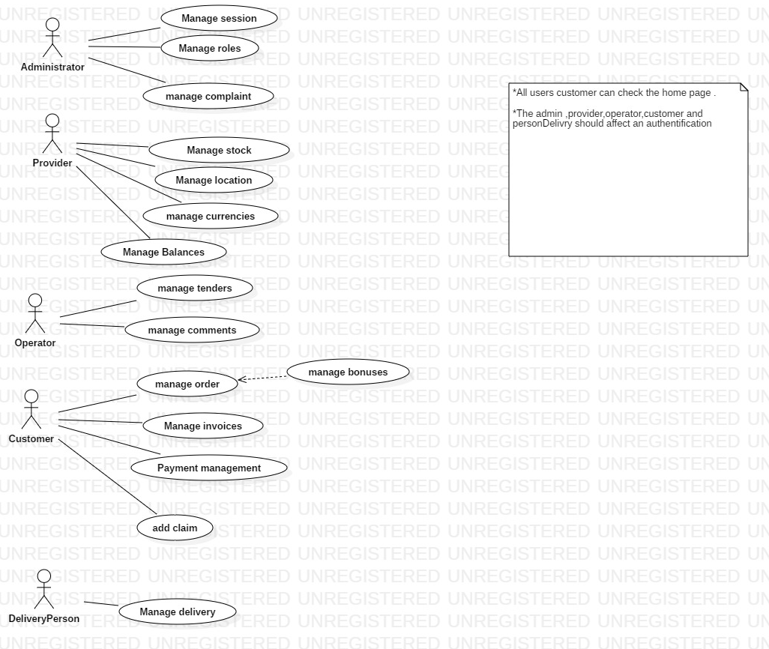General Use cases

Figure 1: General Use Case

In this use case diagram shown in Figure 1, the Customer or user and the provider, operator and administrator interact with the different use cases.

* The Customer can register to create his account. After creating an account, he can log in to the system.
* The user can search for the products or view the products he is looking for.
* The buyer or the user can filter the products by choosing among the different categories and the different products of this category. He can add, update the products in the cart and the buyer can check if he has added the items in the cart. And he can place an order while the supplier or operator can add, and update the products and the category.
* The delivery person can check the list of orders and deliver the orders. And the administrator can manage all users.
  + 1. Conception class diagram

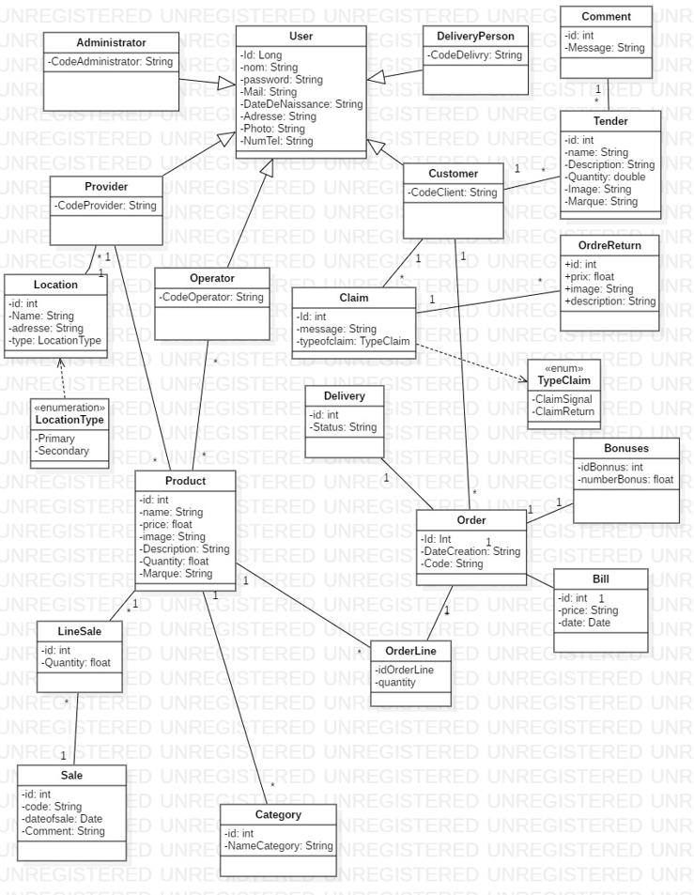We will present the main features of the system as a use cases that identifies the actors who interact with this system while clarifying their roles. The figure below illustrates the general use case diagram of our system.

Figure 2: Analysis class diagram

The global analysis class diagram is the fundamental concept for modeling characteristics and common to behaviors of several objects. It is a conceptual model representing either a real object or an abstract object. It is designated by its name and has attributes and methods. A system generally has several tables. The class diagram details and specifies the table and particularly the type of liaison and association between them as well as their number. The class diagram is considered to be the most widely used in object diagram is part of the UML static model. Following the analysis of the needs of the solution to be implemented and the in study of the working procedure to be respected in this application, we were able to determine the logical components and their interfaces which will end system.

* 1. Global architecture of the solution
     1. Physical Architecture

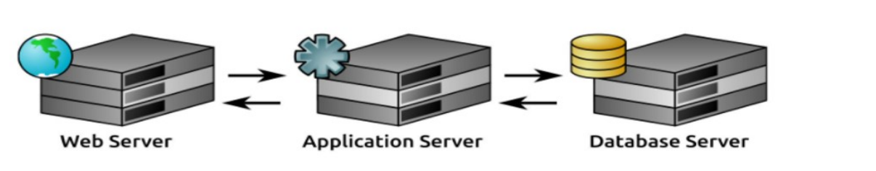The physical architecture is the physical layout of a system and its components in schema.It refers to a representation of a structure or organization of the physical elements of the System.

Figure 3: Physical Architecture

Three-tier architecture is a well-established software application architecture that organizes applications into three logical and physical computing tiers:

* The presentation tier, or user interface.
* The application tier, where data is processed.
* The data tier, where the data associated with the application is stored and managed.

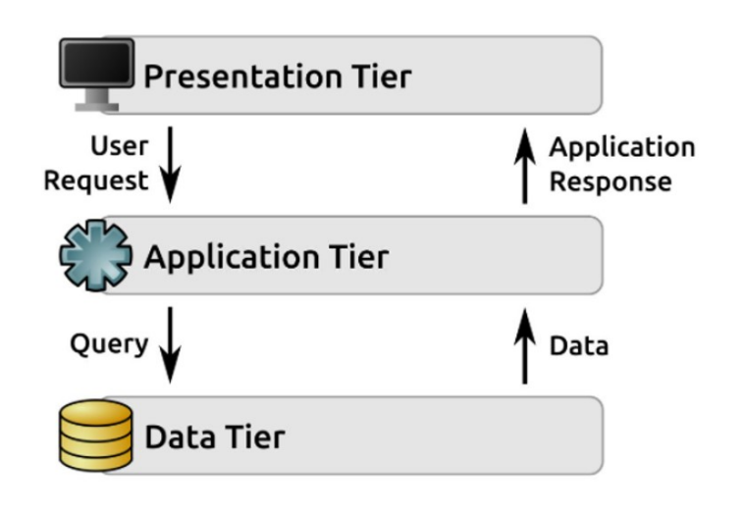

Figure 4: Three-tier architecture

* + 1. Logical Architecture

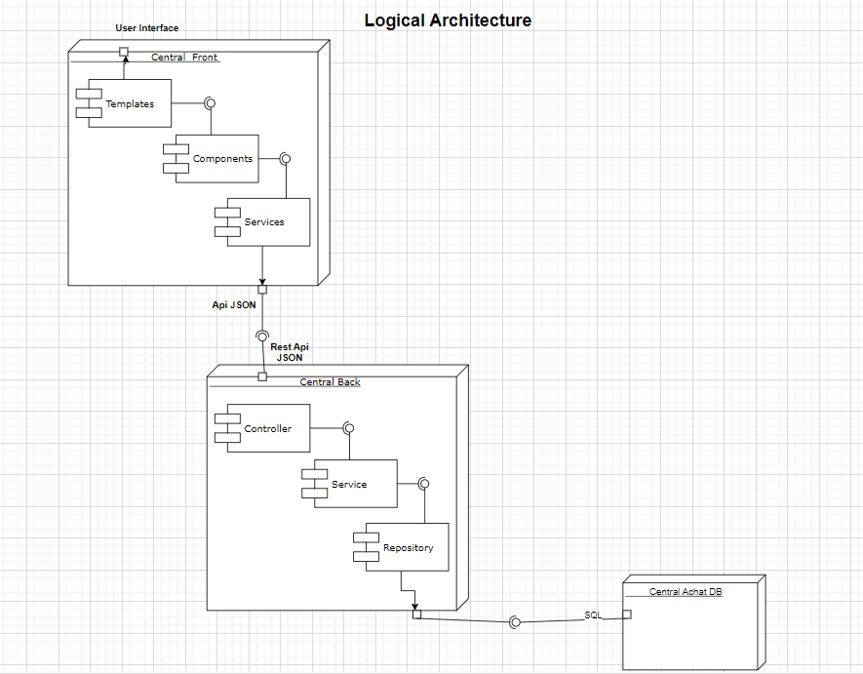The logical architecture definition activity includes decomposing the system into logical components. Logical scenarios are created to describe how the logical components interact to realize each operation of the system block. The internal block diagram of the system defines the interconnection between the logical components. The logical components identified from the initial logical decomposition may be further decomposed and refined to repartition their functionality, stores, and properties.

Figure 5: Logical Architecture

* + 1. MVC

MVC is known as an architectural pattern, which embodies three parts Model, View and

Controller, or to be more exact it divides the application into three logical parts: the

model part, the view and the controller. It was used for desktop graphical user interfaces

but nowadays is used in designing mobile apps and web apps.

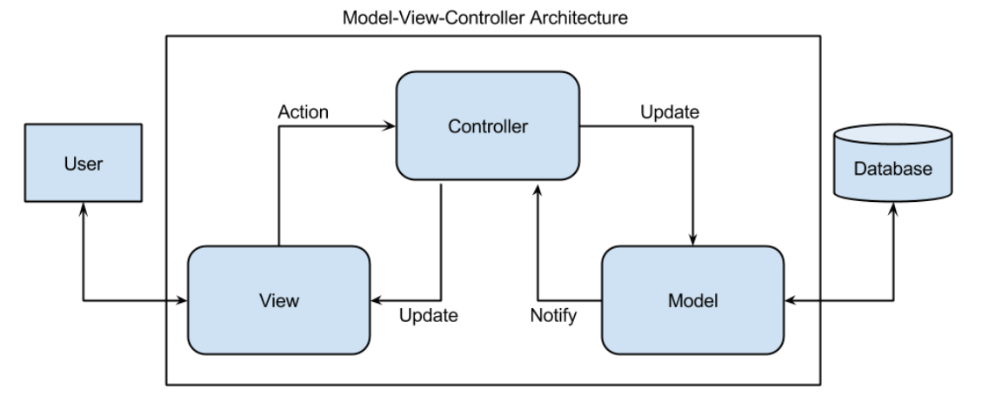

Figure 6: MVC architectural

* + 1. Deployment diagram

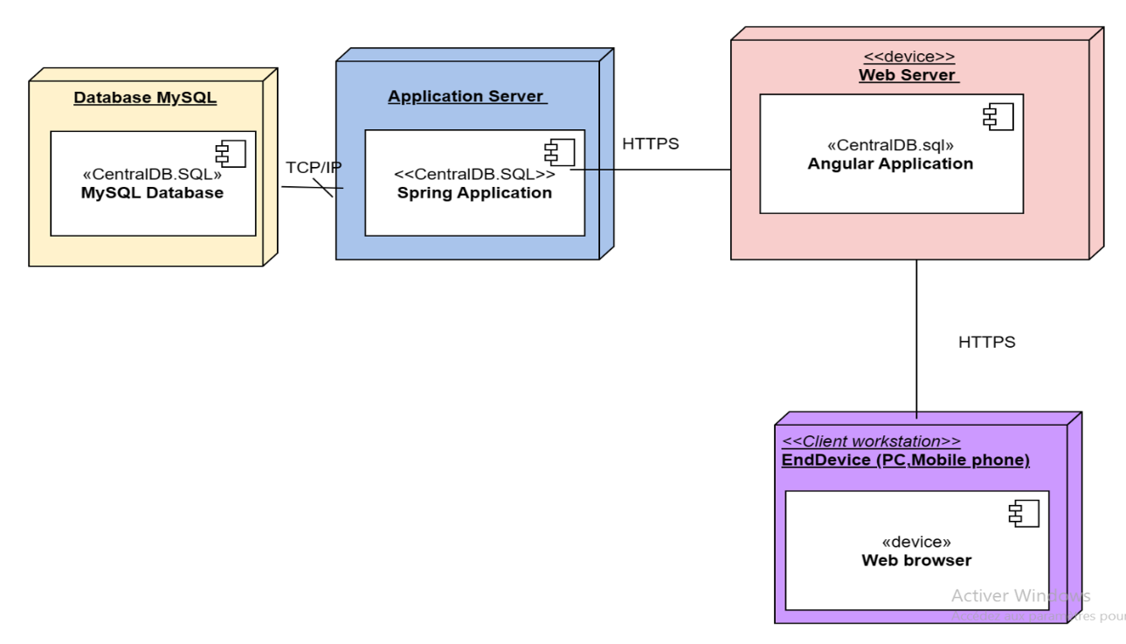A deployment diagram is a static view that is used to represent the use of the physical infrastructure by the system and how the components of the system are distributed and their relationships to each other. The elements used by a deployment diagram are mainly nodes, components, associations and artifacts. The characteristics of physical material resources and communication media can be specified by stereotype.

Figure 7: Deployment diagram

* + 1. Work environment

**Material environment**

In this paragraph, we will introduce the hardware and software environment of development of the application that we used

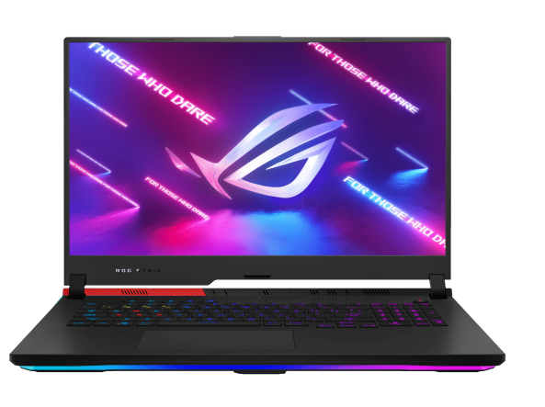

Figure 8: Asus-Rog-Strix

* Brand : Asus
* Processor Amd ryzen 5 5600x
* Memory 16GO DDR4 3200mhz
* Hard drive 512Go NVMe SSD
* Operating system Windows 10

**Operating System**

Windows 11 1 is the latest major release of the Windows NT operating system developed by Microsoft that was announced on June 24, 2021, and is the successor to Windows 10, which was released in 2015. Windows 11 was released to the public on October 5, 2021, as a free upgrade via Windows Update and Windows 11 Installation Assistant on eligible devices running Windows 10

Figure 9:Windows11 Logo.



**Spring Tool Suite (STS) IDE**

Figure 10: Spring Tool Suite (STS) IDE

Spring Tool Suite 2 is an IDE to develop Spring applications.

It is an Eclipse-based development environment. It provides a

ready-to-use environment to implement, run, deploy, and debug

the application. It validates our application and provides quick fixes for the applications.

**IntelliJ IDEA**

IntelliJ IDEA provides a set of inspections that are built-in static code analysis tools. They help you find potential bugs, locate dead code, detect performance issues, and improve the overall code structure

Figure 11: intelli idea

**MySQL Workbench**

MySQL Workbench 4 is a unified visual tool for database architects, developers, and DBAs. MySQL Workbench provides data modeling, SQL development, and comprehensive administration tools for server configuration, user administration, backup, and much more. MySQL Workbench is available on Windows, Linux and Mac OS X.

Figure 12: MySQL

**Lucidchart**

****Lucidchart 5 is a web-based proprietary platform that allows users to collaborate on drawing, revising and sharing charts and diagrams. It is produced by Lucid Software Inc. based in Utah, United States. Lucidchart runs on browsers that support HTML5

Figure 13: Lucidchart

**GitHub**

****GitHub, Inc6 . is a provider of Internet hosting for software development and version control using Git. It offers the distributed version control and source code management functionality of Git, plus its own features

Figure 14: Github

**Spring Boot**

****SpringBoot Logo Spring Boot 7 is an open-source micro framework maintained by a company called Pivotal. It provides Java developers with a platform to get started with an auto configurable production grade Spring application

Figure 15: SpringBoot Logo

**Angular**

Angular8 is a TypeScript-based free and open-source web application framework led by the Angular Team at Google and by a community of individuals and corporations. Angular is a complete rewrite from the same team that built AngularJS.

Figure 16: Angular Logo

**Angular Material**

Angular Material Logo. Angular Material 9 is a User Interface (UI) component library that developers can use in their Angular projects to speed up the development of elegant and consistent user interfaces. Angular Material offers you reusable and beautiful UI components like Cards, Inputs, Data Tables, Datepickers, and much more.

Figure 17: Angular Material

**Bootstrap v4.6**

****Bootstrap is a free and open-source CSS framework directed at responsive, mobile-first front-end web development. It contains CSS and JavaScript-based design templates for typography, forms, buttons, navigation, and other interface components.

Figure 18: Bootstrap

**Conclusion**

In this chapter, we presented Introduction of the project, namely the host organization and the study of the existing. We have also explained the problem and indicated a brief description of the project, the proposed solution as well as the business features specification, we presented also the functional and non-functional Requirements. We have also identified the actors and we have modeled based on the UML language, the global use cases diagram. The next chapter deals with the conception. We will be presenting the diagrams which define the functionality of our application, as well as the Physical and Logical architecture.



General Conclusion

The project was carried out in accordance with the principles of the UP method. Indeed, on a strictly practical level, the method is so profitable for the engineer’s experience, since it is rich with good practices. The work was carried out and in good conditions thanks to the good organization of our team and its professionalism. Given all the conditions and the good working atmosphere, we were able to avoid and anticipate many complications. This project taught us a lot, and it was the first step towards a new domain.